DAILY ASSESSMENT FORMAT
Date: | 20th may 2020 | Name: | Rashmitha
Course: | TCSion | USN: | 4AL17EC077
Topic: | Corporate interviews ,Corporate Etiquette ,email writting | Semester & Section: | 6th B
Github Repository: | Rashmitha

FORENOON SESSION DETAILS
Image of session

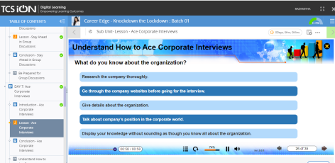

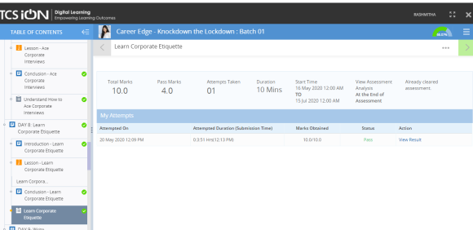

Ace corporate interviews:
What is interview?
- Interview is a widely used process of screening applicants for job
- It provides the most direct information about candidate his/her skills,background and personality type

Preparation for job interview:
It includes 4 ps:
1.Prepare
2.Practice
3.Present
4.Participate

Preparation of an effective interview includes:
- A good assessment of ourself
- Researching the organization
- Updating our resume
- Preparing a list of commonly asked questions
- Dress appropriately as per the corporate setting
- Reach 10-15 minutes early

Frequently asked questions in interview:
Tell me something about urself!
- Be brief while responding
- Don’t include the life history nor irrelevant details
- Talk about relavant work experience ,achievement and expertise
- Show our interest in joining
- A brief on our carrier objectives should be given
- Talk about our strengths and skills that we have to offer to them

Learn corporate etiquette:
What is business etiquette?
Business etiquette can be defined as all the rules that one has to follow when in a business environment

Basic rules:
- Greeting
- Business cards
- Introductions
- Language used
- Distance while communicating
- Personal details
- Personal hygiene

Write effective emails:
- Some good opening lines
- Use a strong subject line
- Type the correct email id
- Keep our email short
- Write about only one topic in one mail
- Use correct spelling and grammer
- Proofread all our emails before sending them
- Password protects the important attachments
- Carbon copy(cc) only to concerned people only
- Use numbering and bullets
- Don’t use all upper case or all lower case.

Date:20 may 2020 |  | Name:Rashmitha
Course:python |  | USN:4AL17EC077
Topic:Application |  | Semester & Section: 6th B
AFTERNOON SESSION DETAILS
Image of session

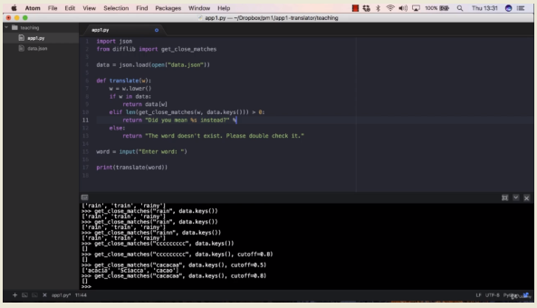

Application 1:build an interactive English dictionary

This program will explain about the real time example that includes the creating a English dictionary. By using this program we can find the meaning of any English word. To perform this action we are importing a file called “data.json”. This is an text file which contains all the words snd their meanings.

Program 1:
import json
data=json.load(open(“data.json”)
def translate(w):
return data(w)
word=input(“enter word:”)
print(translate(word))
output:
>>>python3.app1.py
enter word:rain
[‘precipitation in the form of liquid water drops with diameter greater than 0.5 millimeter’]

This is the basic program to search the meaning of a word. But this will work only if we enter the input word correctly. If we give the word which is not there in that data.json file then it will give the error and we are not able to get the output.

Program 2:
import json
data=json.load(open(“data.json”)
def translate(w):
if w in data:
return data(w)
else:
return “The word doesn’t exist .please double check it”
word=input(“enter word:”)
print(translate(word))
output:
>>>python3.app1.py
enter word:rain
[‘precipitation in the form of liquid water drops with diameter greater than 0.5 millimeter’]
>>>python3.app1.py
enter word:rainn
“The word doesn’t exist .please double check it”

If we enter the input as upper case letters then it will show as error so we need to modify this program to give the output for upper case letters. The modified program is as shown bellow
Program 3:
import json
data=json.load(open(“data.json”)
def translate(w):
w=w.lower()
if w in data:
return data(w)
else:
return “The word doesn’t exist .please double check it”
word=input(“enter word:”)
print(translate(word))
output:
>>>python3.app1.py
enter word:rain
[‘precipitation in the form of liquid water drops with diameter greater than 0.5 millimeter’]
>>>python3.app1.py
enter word:RAIN
[‘precipitation in the form of liquid water drops with diameter greater than 0.5 millimeter’]

Program4:
import json
data=json.load(open(“data.json”)
def translate(w):
w=w.lower()
if w in data:
return data(w)
elif len(get_close_matches(w,data.keys()))>0:
yn=input(“Did you mean %s instead? Enter Y if yes,or N if no:”%get_close_matches(w’data.keys())[0])
if yn==”Y”
return data[get_close_matches(w,data.keys())[0])
else:
return “We didn’t understood your entry.”
else:
return “The word doesn’t exist .please double check it”
word=input(“enter word:”)
print(translate(word))

output:
python3.app1.py
enter word:rain
[‘precipitation in the form of liquid water drops with diameter greater than 0.5 millimeter’]
>>>python3.app1.py
enter word:rainnn
Did you mean instead? Enter Y if yes,or N if no:Y
[‘precipitation in the form of liquid water drops with diameter greater than 0.5 millimeter’]
>>>python3.app1.py
enter word:bvfesxvggxdd
Did you mean instead? Enter Y if yes,or N if no:N
“We didn’t understood your entry”
>>>python3.app1.py
enter word:mountain
[‘A mountain is a large landform that rises above the surrounding land area,usually in the form of peak.’]

